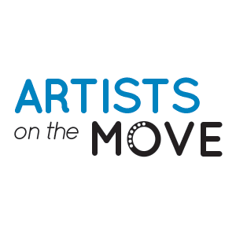

COVID-19 LIABILITY RELEASE WAIVER:

Due to the outbreak of Covid-19 our business is taking extra precautions with the care of every client to include health history review and enhanced sanitation/disinfecting procedures in compliance with the CDC guidance.

Symptoms of Covid-19 include:

- Fever
- Fatigue
- Dry Cough
- Difficulty Breathing

I agree to the following:

- I understand the above symptoms and affirm that I, as well as all household members, do not currently have, nor have experienced the symptoms listed above within the last 14 days.
- I affirm that I, as well as all household members, have not been diagnosed with Covid-19 within the past 30 days.
- I affirm that I, as well as all household members, have not knowingly been exposed to anyone diagnosed with Covid-19 within the past 30 days.
- I affirm that I, as well as household member, have not traveled outside of the country or to any city considered to be a “hot spot” for Covid-19 infections within the past 30 days.
- I understand that Artists on the Move and the All You Got Tour, LLC cannot be held liable for any exposure to the Covid-19 virus caused by misinformation on this form or the health history provided by each client.

Our business is following these enhanced procedures to prevent the spread of Covid-19 through instituting safety procedures at all shows, events and sessions going forward. We will have tables set up with disinfectant and will have our show policy visible to all attendees. This process will include an evaluation of the venue and their respective Covid-19 policies and procedures, a Covid-19 safety plan for the event, proper positioning of the artists in relation to the audience, and a gig sheet which will summarize all show details relative to Covid-19.

The Artists on the Move and the All You Got Tour, LLC Covid-19 policy is contained on the Artists on the Move website.

By signing below, I agree to each statement and release Artists on the Move and the All You Got Tour from any and all liability for unintentional exposure or harm due to Covid-19. Please contact our staff at 978-758-0823 should you have any questions.

By signing below,

